

KAUNAS UNIVERSITY OF TECHNOLOGY

FACULTY OF INFORMATICS

T120B166 Development of Computer Games and Interactive Applications

*Eternal Struggle*

|  |
| --- |
| *IFZm-1, Ernestas Kuprys* |
|  |
| Date: 2024*.05.28* |

Kaunas, 2024

Tables of Contents

Tables of Images 4

Table of Tables/functions 5

Work Distribution Table: 6

Description of Your Game 7

Laboratory work #1 8

List of tasks 8

Solution 8

Task #1. *Create a base enemy and give it AI.* 8

Task #2. *Program a damage system for enemies.* 9

Task #3. *Add a working health bar to enemies.* 11

Task #4. *Spawn enemies on death (defense 1).* 13

Laboratory work #2 14

List of tasks 14

Solution 14

Task #1. *Build an island location.* 14

Task #2. *Design a new weapon system.* 15

Task #3. *Allow the user to wield up to 2 weapons and freely swap between them.* 16

Task #4. *Show equipped user weapons.* 18

Task #5. *Play a shooting animation for each weapon.* 18

Task #6. *Add a crosshair.* 19

Task #7. *Replace player character model.* 20

Task #8. *Add ammo and score counters (defense 2).* 20

Laboratory work #3 21

List of tasks 21

Solution 22

Task #1. *Make shot bullets fly towards the screen reticle.* 22

Task #2. *Allow for bullet penetration on hit scan.* 22

Task #3. *Blend weapon carrying animation with running.* 23

Task #4. *Apply viewport y axis rotation to the player character.* 24

Task #5. Apply a new enemy model with animations. 25

Task #6. Add enemy-to-player damage system. 26

Task #7. Display player taken damage visually as blood splatters. 27

Task #8. Add enemy attack animation blend. 28

Task #9. Design an enemy wave spawn system. 29

Task #10. Add a weapon/ammo purchase mechanic. 30

Task #11. Add main menu. 32

Task #12. Add game over menu. 33

Task #13. Add pause menu. 35

User's manual 37

Literature list 39

ANNEX 40

# **Tables of Images**

Figure 1 Enemy movement 8

Figure 2 Dead enemy 10

Figure 3 Healthbar layout 11

Figure 4 Healthbar display 12

Figure 5 Multiple enemies spawned 13

Figure 6 Created island 15

Figure 7 New weapon classes 15

Figure 8 BP_WeaponMaster attributes 16

Figure 9 Weapon pickup blueprints 16

Figure 10 Player character variables 17

Figure 11 Weapon socket placement 18

Figure 12 Pistol fire animation 19

Figure 13 Crosshair 19

Figure 14 UI widget code 19

Figure 15 Skeleton mesh settings 20

Figure 16 Screenshot with ammo and point counters 20

Figure 17 Multiple targets hit at once 23

Figure 18 Player looking at floor shadow 24

Figure 19 Applied enemy model 26

Figure 20 Applied enemy model 27

Figure 21 Blood splatter on screen 28

Figure 22 Enemy attack animation 29

Figure 23 Purchase display 31

Figure 24 Main menu 32

Figure 25 Game over menu 34

Figure 26 Pause menu display 35

Figure 27 Executable file location 37

Figure 28 Application starting screen 37

Figure 29 Game over screen 38

# **Table of Tables/functions**

Table 1 AI movement 9

Table 2 Hit detecion 10

Table 3 Damage function 10

Table 4 Death function fragment 11

Table 5 Healthbar update function 12

Table 6 Expanded death function 13

Table 7 Spawn function 14

Table 8 Increase counter on BeginPlay 14

Table 9 Weapon fire logic 16

Table 10 Weapon pickup code 17

Table 11 Player given weapon code 17

Table 12 Weapon swap code 17

Table 13 Weapon display code. 18

Table 14 Animation code 19

Table 15 Ammo display code 21

Table 16 Point display code 21

Table 17 Line trace (shot) code with point inrease added 21

Table 18 Altered hit scan code fragment 22

Table 19 Bullet penetration code fragment 23

Table 20 Rotation calculation 25

Table 21 Expanded upper body animation state 25

Table 22 Enemy damage function 27

Table 23 Health display code 28

Table 24 Enemy animation blueprint 29

Table 25 Wave start function 30

Table 26 Enemy spawn logic 30

Table 27 Weapon purchase code fragment 31

Table 28 Weapon display logic 32

Table 29 Button functions 33

Table 30 Game over logic 34

Table 31 GameInstance class 35

Table 32 Pause function logic 36

# **Work Distribution Table:**

|  |  |
| --- | --- |
| ***Name/Surname*** | ***Description of game development part*** |
| *Ernestas Kuprys* | Programmer, responsible for the entire project. |

# **Description of Your Game**

Description of Your Game.

1. “Eternal Struggle” is a 3D game that’s inspired by the “Call of Duty” zombies mode as well as the “Doom” franchise.
2. Game type: “Eternal Struggle” is a survival shooter, where your goal is to either find a way to escape or to survive as long as you can.
3. Game genre: survival, first person shooter (fps).
4. Platforms: PC.
5. You play as a convict that’s been sent to a desolate location, devoid of any living humans, as punishment for the crimes you’ve committed. There, you are tasked to fight endless waves of monsters and otherworldly creatures for the amusement of the audience watching. Will you dedicate your life to entertaining the audience by fighting endless hordes or will you desperately search for a way out of this nightmare?

# **Laboratory work #1**

**List of tasks**

1. Create a base enemy and give it AI.
2. Program a damage system for enemies.
3. Add a working health bar to enemies.
4. Spawn enemies on death (defense 1).

# **Solution**

## **Task #1. *Create a base enemy and give it AI.***

A default third person template mannequin was used as a base for an enemy. Enemy detection was achieved with the use of the PawnSensing component. This component along with the AI MoveTo method allows the enemy to track the location of the player.

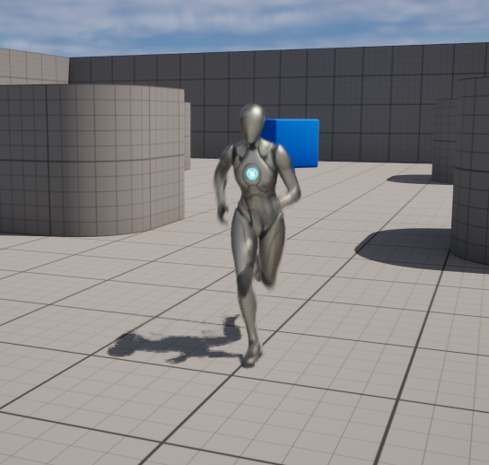

Figure 1 Enemy movement

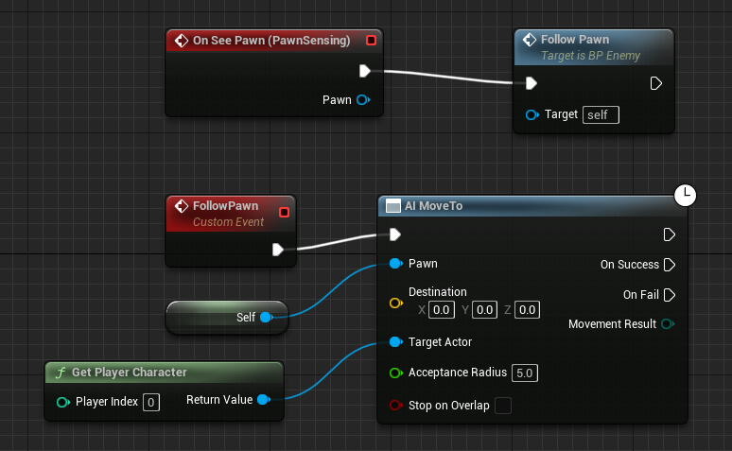

Table 1 AI movement

## **Task #2. *Program a damage system for enemies.***

A damage system was achieved by referencing the “On component Hit” event under the Mesh blueprint component. From there it was possible to create a function for receiving damage and death. A “health” variable was added to the enemy blueprint as well as a “damage” variable to the bullets.

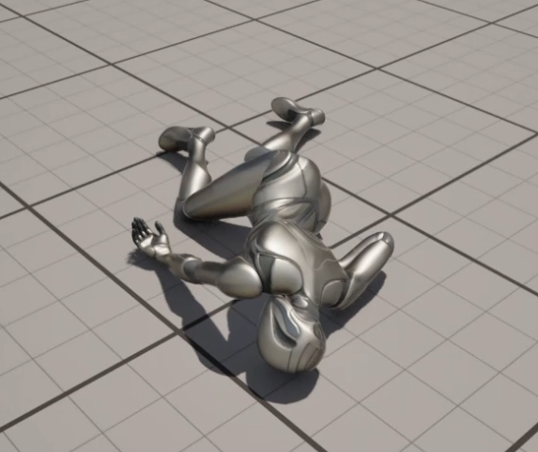

Figure 2 Dead enemy

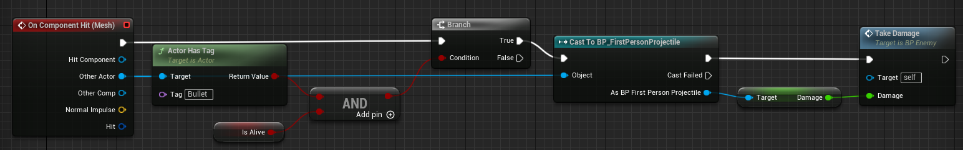

Table 2 Hit detecion

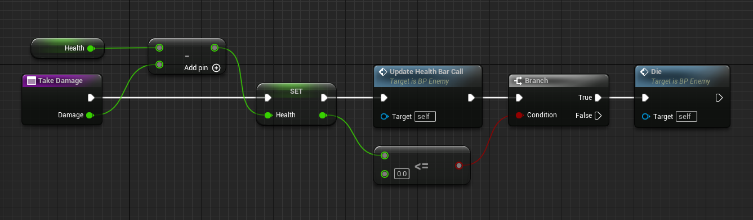

Table 3 Damage function

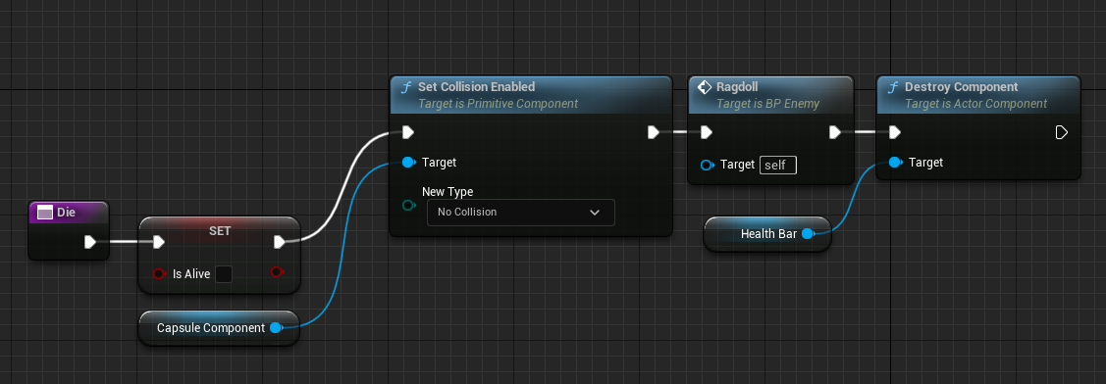

Table 4 Death function fragment

## **Task #3. *Add a working health bar to enemies.***

A working health bar was implemented with the use of a widget blueprint. The health bar itself was created with a “Progress Bar” widget and applied above the head of the enemy. And its percentage value was calculated based off the difference between enemy current health and max health.

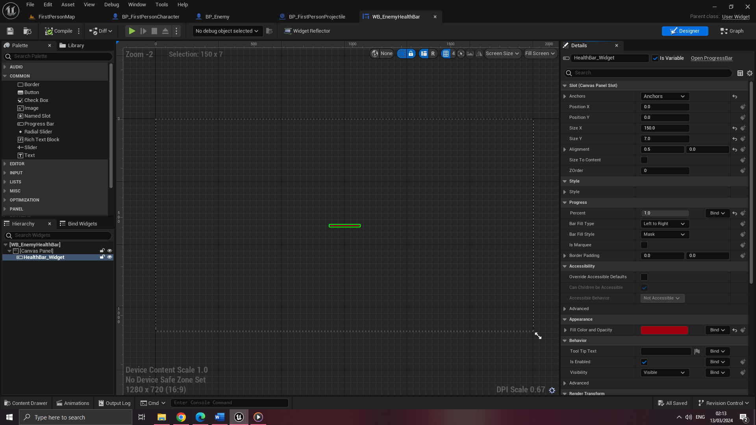

Figure 3 Healthbar layout

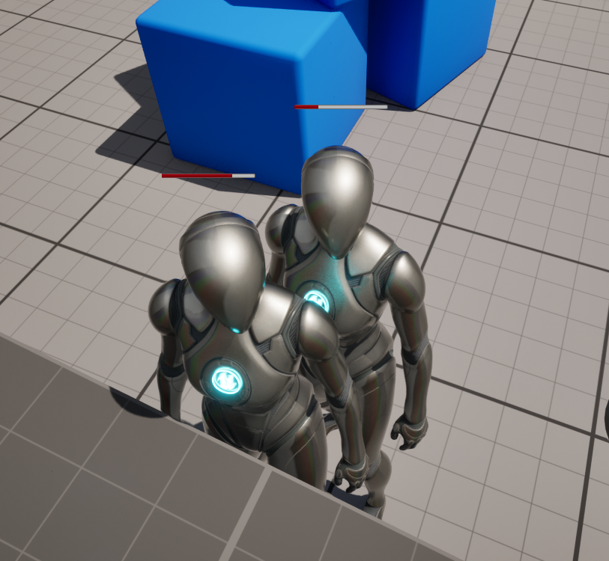

Figure 4 Healthbar display

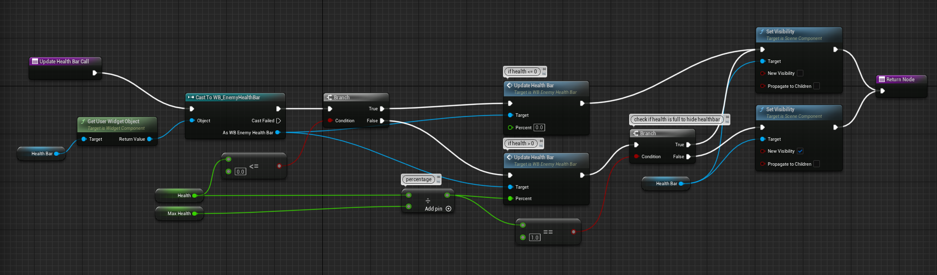

Table 5 Healthbar update function

## **Task #4. *Spawn enemies on death (defense 1).***

To increase the number of enemies spawned twofold on every enemy death, variables were created in the player pawn blueprint detailing the current difficulty (amount of times spawn number increased) and the active enemy count.

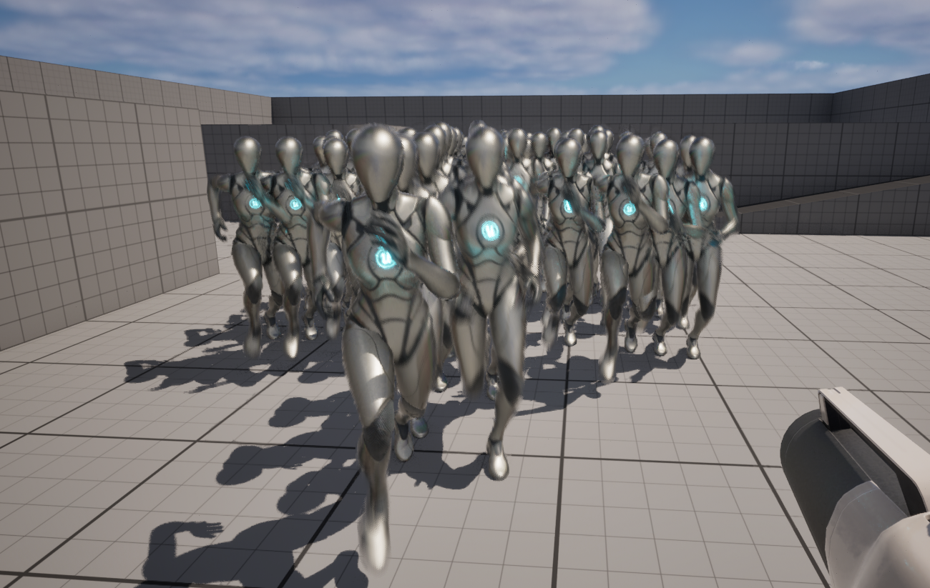

Figure 5 Multiple enemies spawned

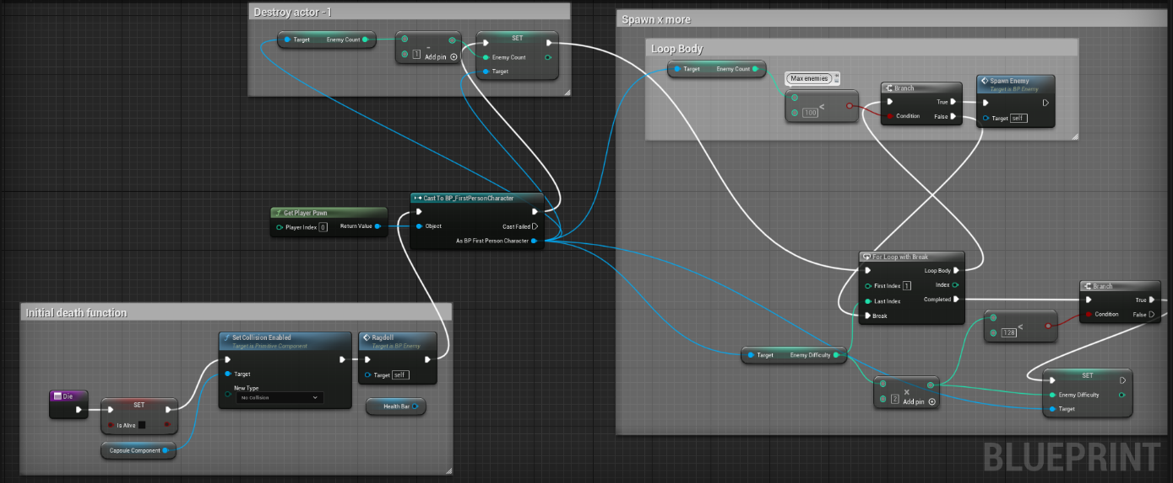

Table 6 Expanded death function

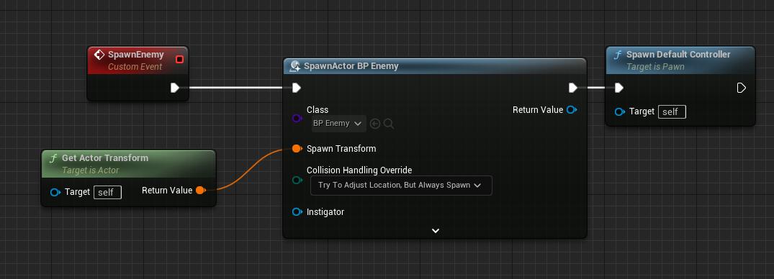

Table 7 Spawn function

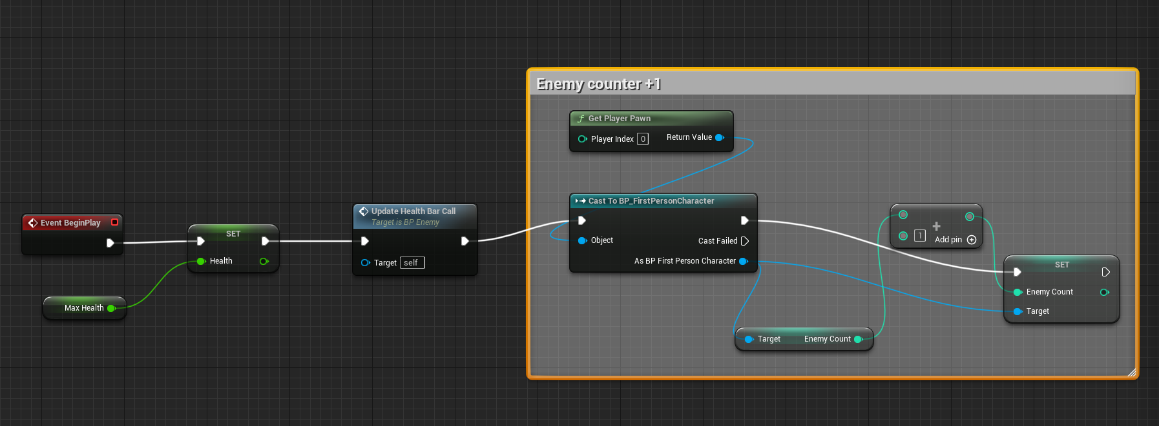

Table 8 Increase counter on BeginPlay

# **Laboratory work #2**

**List of tasks** (main functionality of your project)

1. Build an island location.
2. Design a new weapon system.
3. Allow the user to wield up to 2 weapons and freely swap between them.
4. Show equipped user weapons.
5. Play a shooting animation for each weapon.
6. Add a crosshair.
7. Replace player character model.
8. Add ammo and score counters (defense 2).

# **Solution**

## **Task #1. *Build an island location.***

Island creation was achieved with “Landmass” and “Water” plugins. First the sculpting was done with a “*CustomBrush_Landmass”* brush. Then a “*Water Body Ocean”* class was used for the surrounding water. The grass material was imported from a UE marketplace asset “Easy Building System v10”.

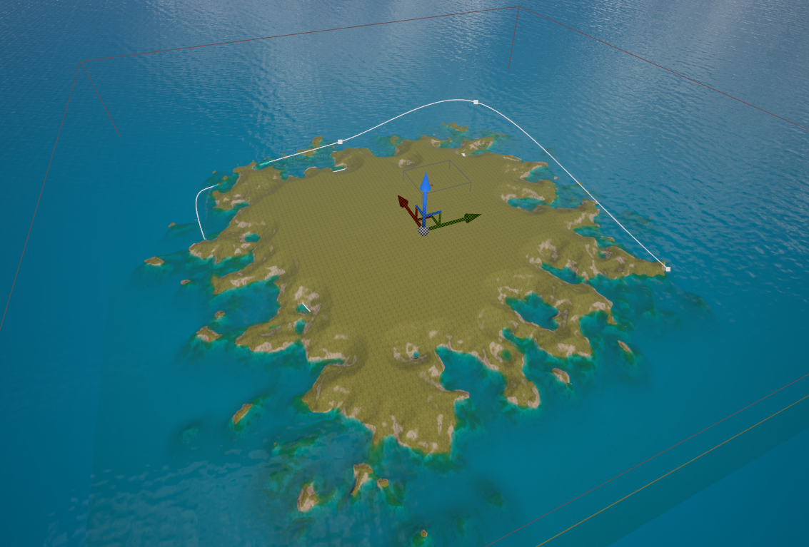

Figure 6 Created island

## **Task #2. *Design a new weapon system.***

A base weapon blueprint class was created called “BP_WeaponMaster” thay detail common weapon variables: damage, ammo, weapon type and more. Then 3 weapons were created by inheriting this blueprint, each with their own weapon model. Weapon assets were taken from “Military Weapons Dark” in UE asset marketplace.

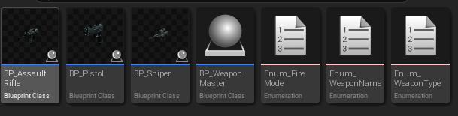

Figure 7 New weapon classes

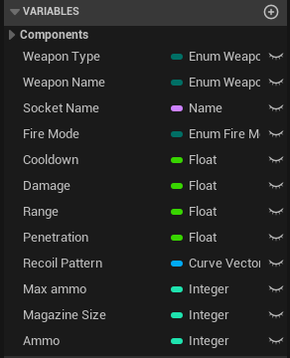

Figure 8 BP_WeaponMaster attributes

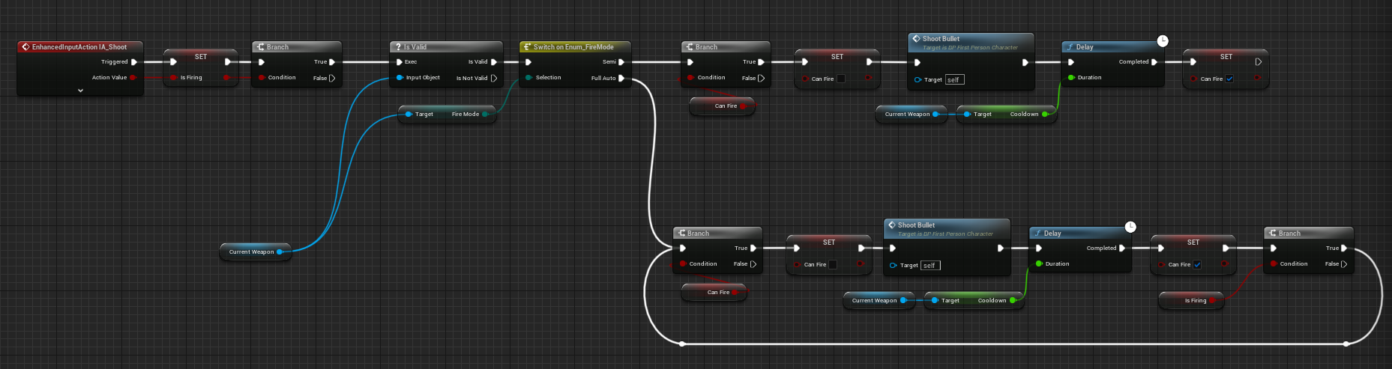

Table 9 Weapon fire logic

## **Task #3. *Allow the user to wield up to 2 weapons and freely swap between them.***

Each weapon has their own pickup blueprint class, which extends *BP_WeaponPickup*. Weapon instances are stored in “*Weapons”* array, and equipped weapon is stored as “*Current Weapon” along with its array index.* When player has 2 weapons and tries to pick up another, the current one will be destroyed in place of the new one.

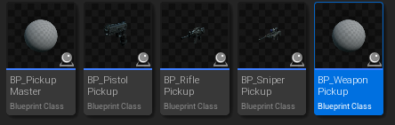

Figure 9 Weapon pickup blueprints

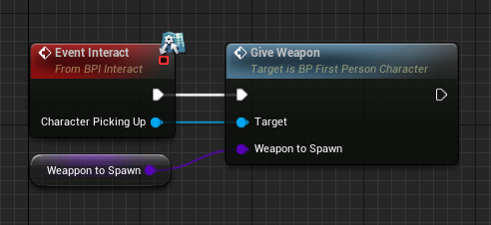

Table 10 Weapon pickup code

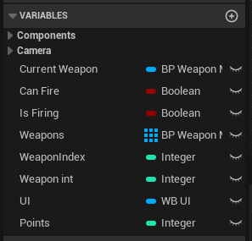

Figure 10 Player character variables

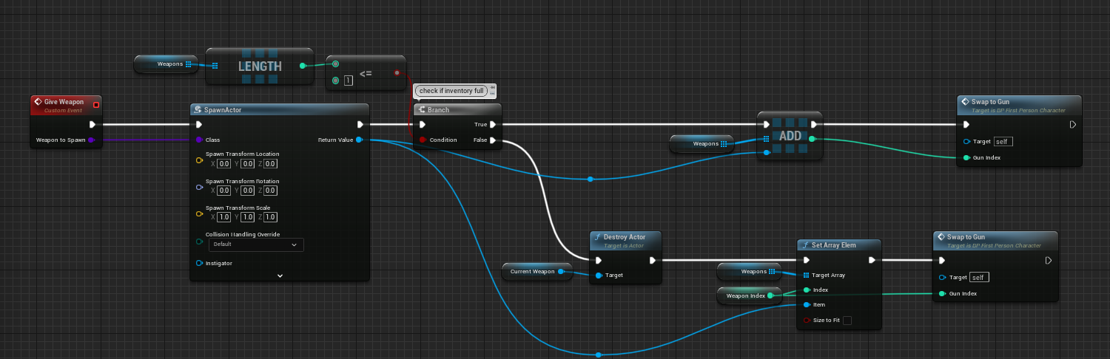

Table 11 Player given weapon code

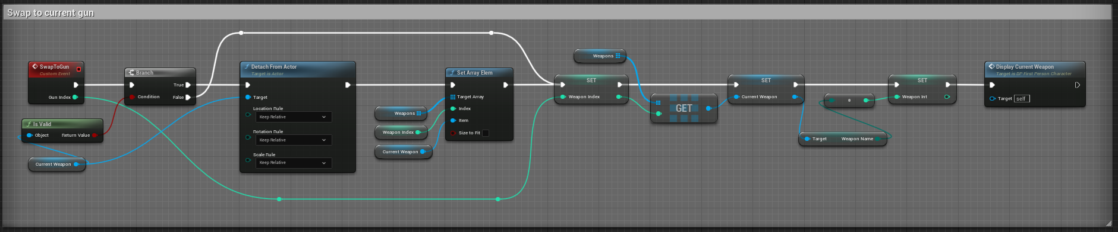

Table 12 Weapon swap code

## **Task #4. *Show equipped user weapons.***

Display of equipped weapons was achieved by adding sockets to player skeleton. On weapon swap, those weapons would be attached to their appropriate socket. Each weapon must have an existing socket name declared in their variables.

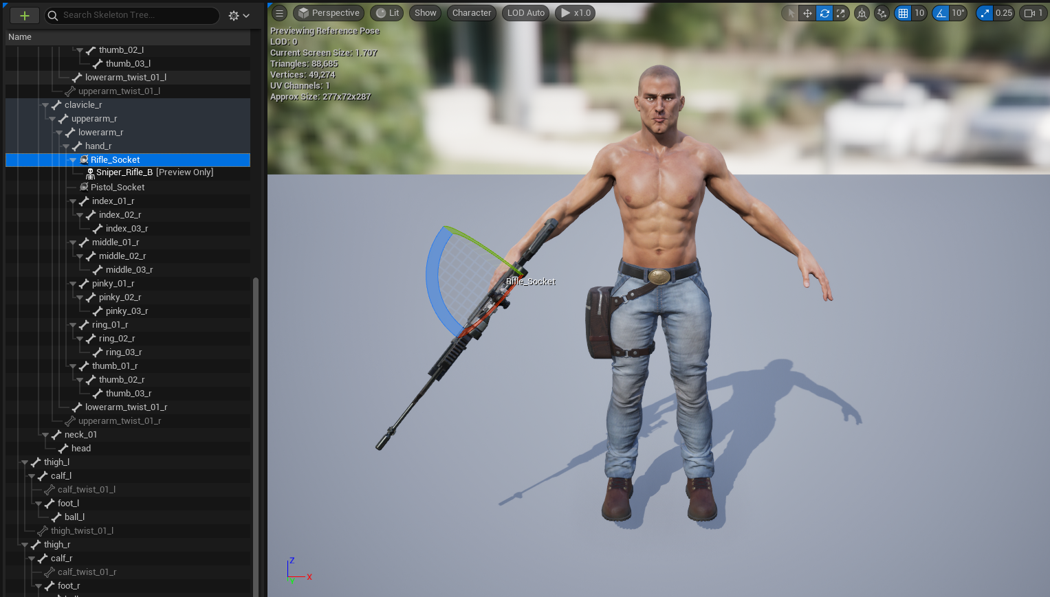

Figure 11 Weapon socket placement

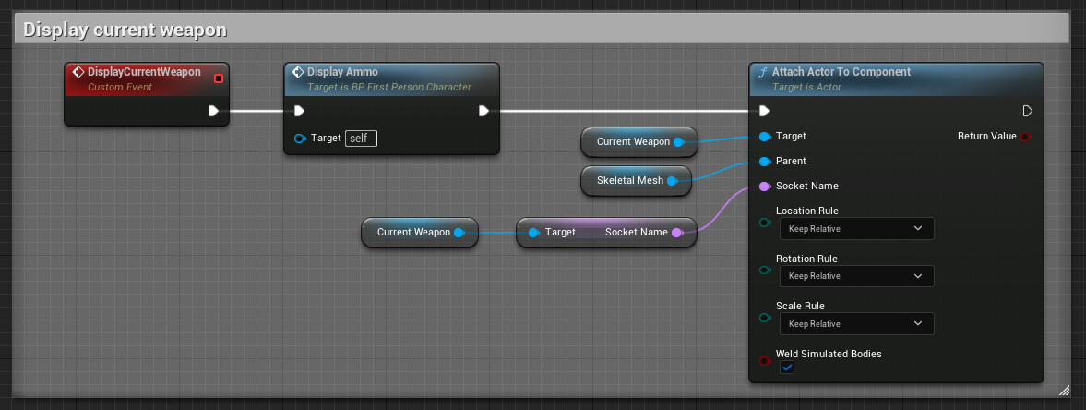

Table 13 Weapon display code.

## **Task #5. *Play a shooting animation for each weapon.***

Shooting animations are declared for each gun individually. Weapon shooting animations are included in “Military Weapons Dark” for each weapon.

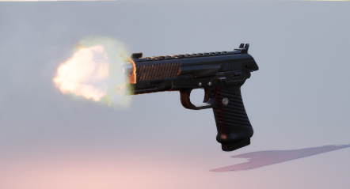

Figure 12 Pistol fire animation

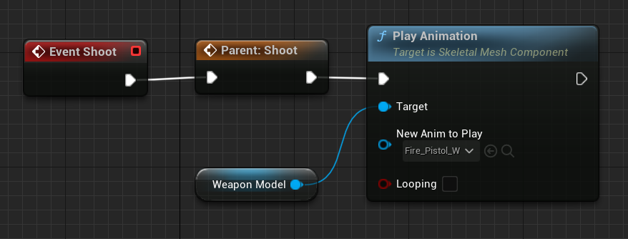

Table 14 Animation code

## **Task #6. *Add a crosshair.***

A crosshair was implemented using a widget blueprint. Inside “*BP_UI*” multiple image items were used to display a crosshair. Later the UI blueprint was attached to the player character.

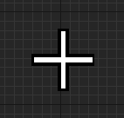

Figure 13 Crosshair

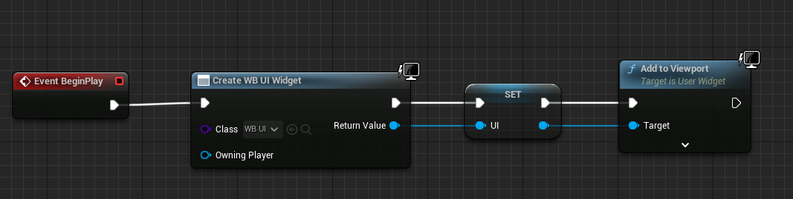

Figure 14 UI widget code

## **Task #7. *Replace player character model.***

By importing the “Third Person” pack, you get access to the full mannequin rig. Then in your character blueprint you can set your mesh to the desired imported character. In this case the character from “*Adventure Character*” UE marketplace was based off UE4 mannequin model, so retargeting the UE5 mannequin animation assets was also required.

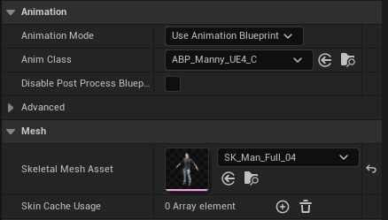

Figure 15 Skeleton mesh settings

## **Task #8. *Add ammo and score counters (defense 2).***

Ammo and score text fields were added to the UI widget. Upon shooting a bullet ammo gets reduced by 1. Upon dealing damage points increase by 10.

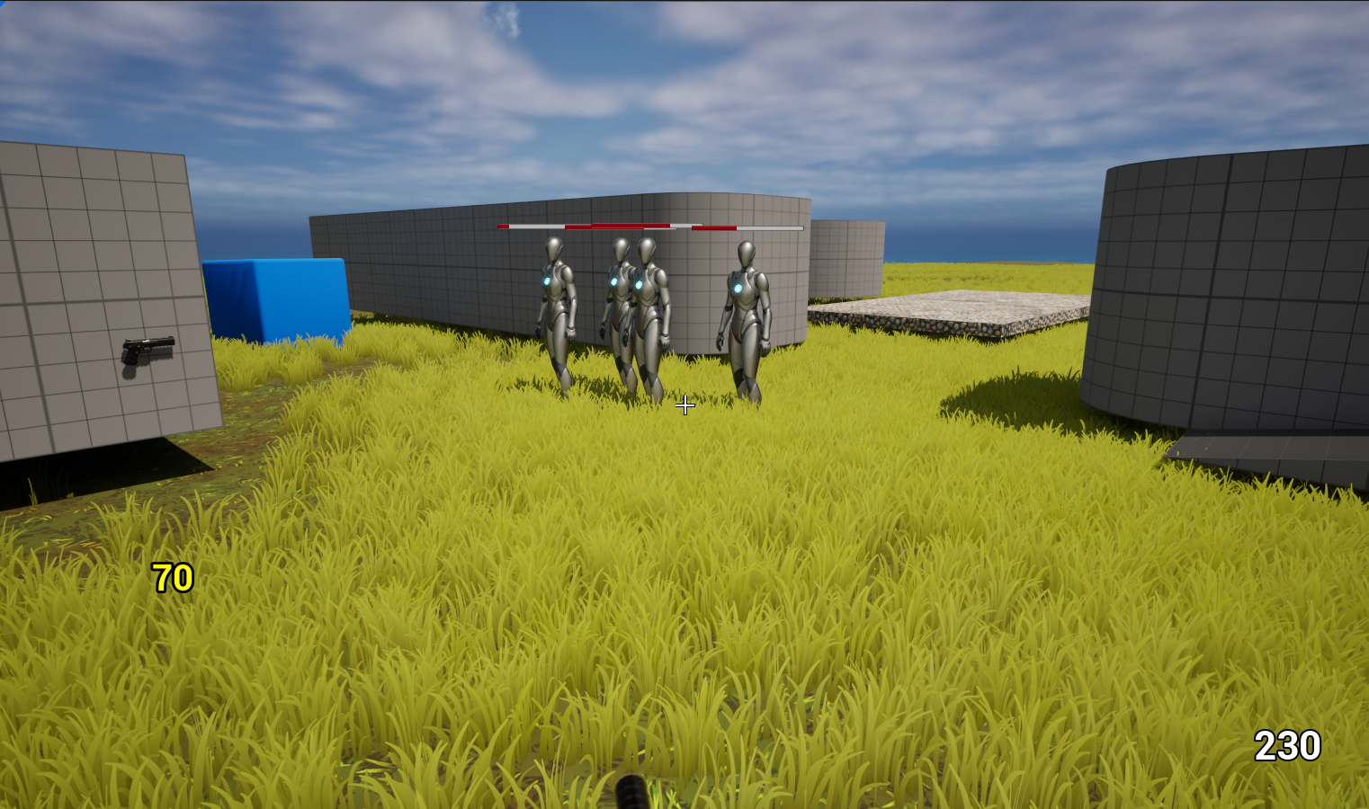

Figure 16 Screenshot with ammo and point counters

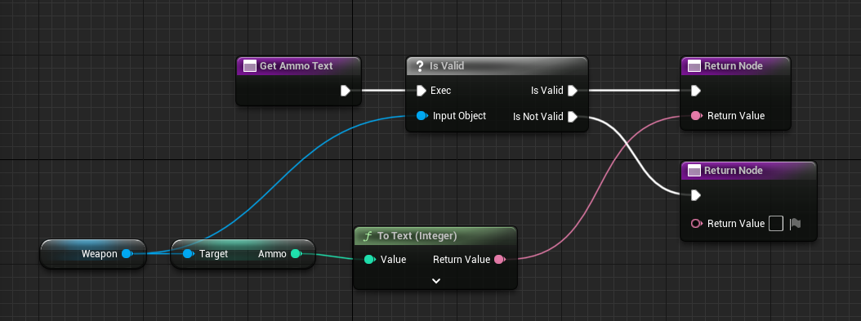

Table 15 Ammo display code

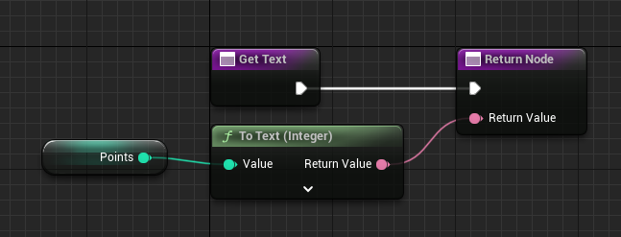

Table 16 Point display code

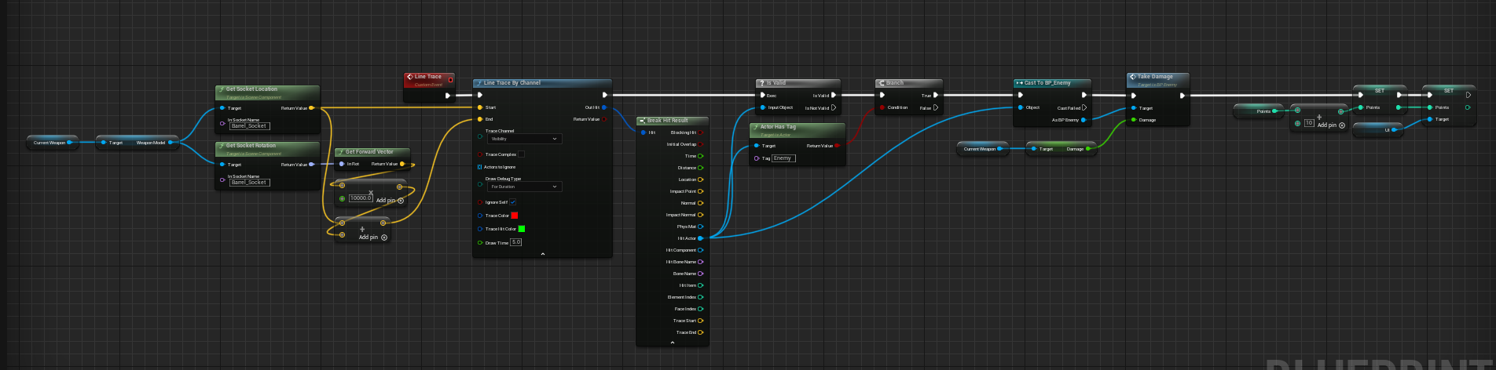

Table 17 Line trace (shot) code with point inrease added

# **Laboratory work #3**

**List of tasks** (main functionality of your project)

1. Make shot bullets fly towards the screen reticle.
2. Allow for bullet penetration on hit scan.
3. Blend weapon carrying animation with running.
4. Apply viewport y axis rotation to the player character.
5. Apply a new enemy model with animations.
6. Add enemy-to-player damage system.
7. Display player taken damage visually as blood splatters.
8. Add enemy attack animation blend.
9. Design an enemy wave spawn system.
10. Add a weapon/ammo purchase mechanic.
11. Add main menu.
12. Add game over menu.
13. Add pause menu.

# **Solution**

## **Task #1. *Make shot bullets fly towards the screen reticle.***

For bullets to fire at a proper angle, the starting shot position should be set to the player’s viewpoint. Then set the line end point with “Get Forward Vector” method.

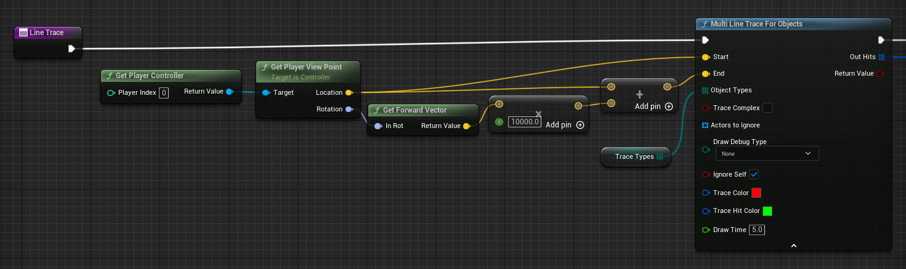

Table 18 Altered hit scan code fragment

## **Task #2. *Allow for bullet penetration on hit scan.***

Bullet penetration is achieved by changing the “Line Trace By Channel” to “Multi Line Trace For Object”. However, this causes a new issue: single bullets hitting the same enemy multiple times on different components. This issue can be resolved by adding all hit component actors to an array and skipping addition if the entry already exists. If the entry is unique, then apply damage.

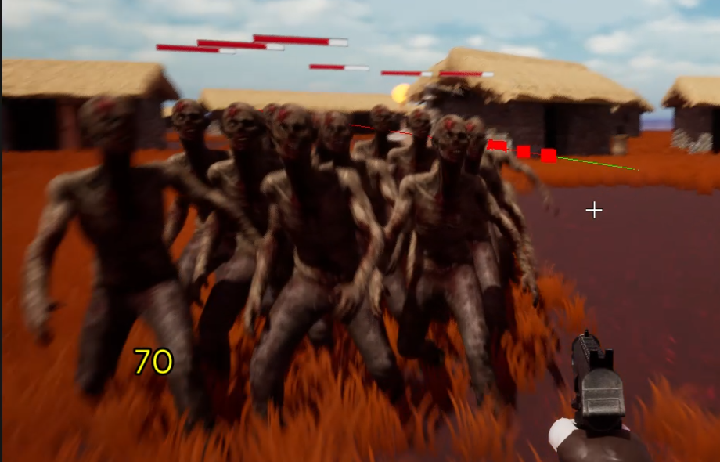

Figure 17 Multiple targets hit at once

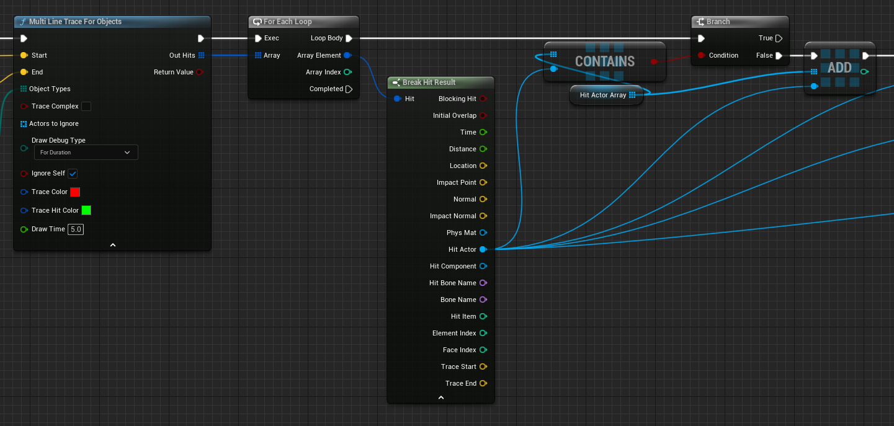

Table 19 Bullet penetration code fragment

## **Task #3. *Blend weapon carrying animation with running.***

To blend animations together, several states for individual weapon carry animations were created. Their state is determined an integer inside the player script, which is updated on gun display. The weapon and running animations were then mixed with a “Layer blend per bone” node, which blends 2 animation states together from a selected bone up. In this case the selected bone is “spine_03”. Along with that, mesh space rotation blend and mesh space scale blend are set to true.

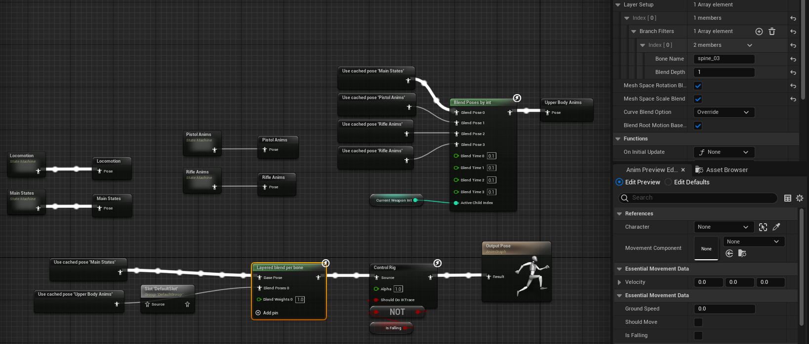

## **Task #4. *Apply viewport y axis rotation to the player character.***

To apply viewport rotation to character, first, the required rotation value should be calculated. Divide the value by 3 and then apply it to 3 separate spine bones to simulate back folding. This allows the user to look up and down and have the pointed gun follow their view.

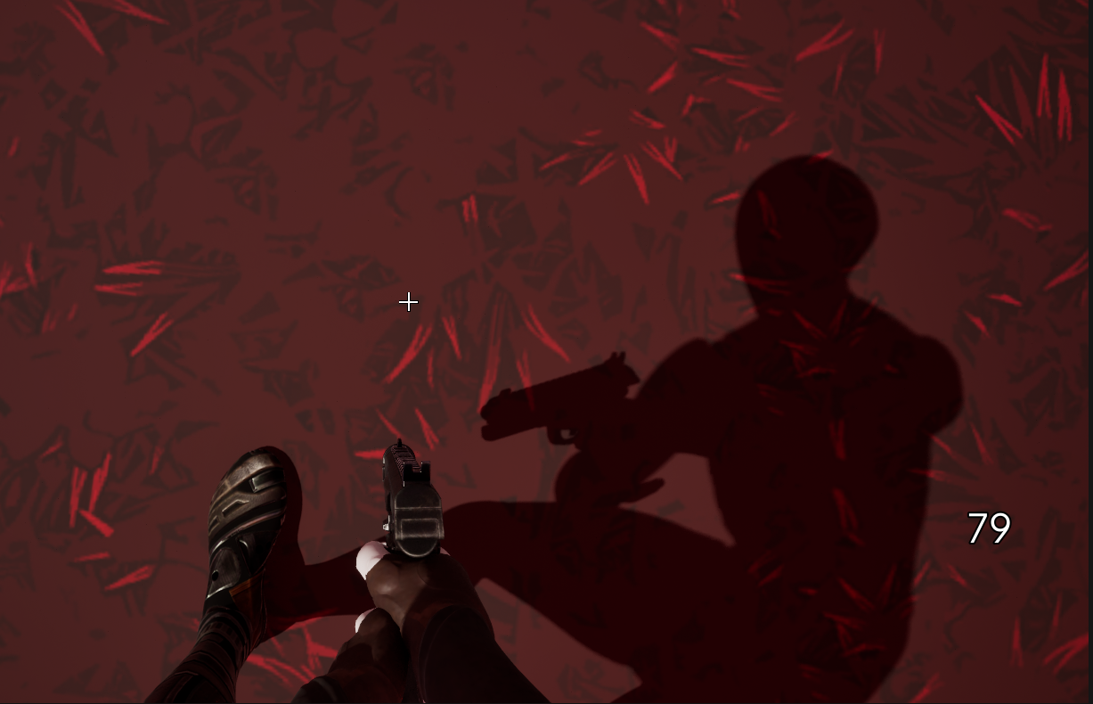

Figure 18 Player looking at floor shadow

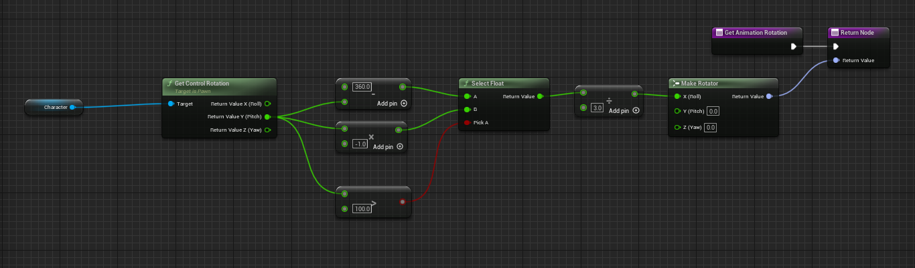

Table 20 Rotation calculation

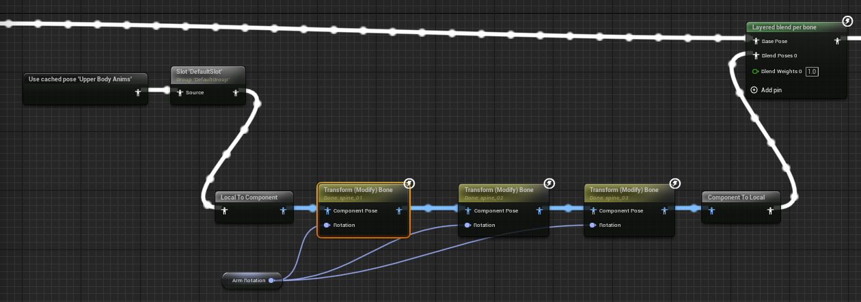

Table 21 Expanded upper body animation state

## **Task #5. Apply a new enemy model with animations.**

A zombie model and animations were sourced from Mixamo [6]. The pre-rigged .FBX model had then been imported and a skeleton was created from it. Afterwards, the selected animations are then imported with the new zombie skeleton used as a reference.

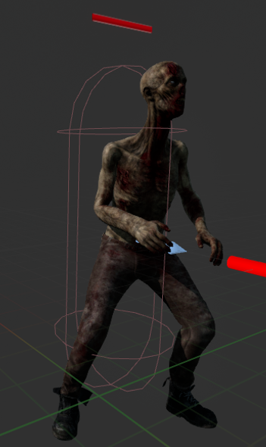

Figure 19 Applied enemy model

## **Task #6. Add enemy-to-player damage system.**

An enemy-to-player damage system was achieved by spawning a sphere collider whenever an enemy reached its target with “AI MoveTo”. This sphere is then checked for overlapping actors who will have damage applied to them.

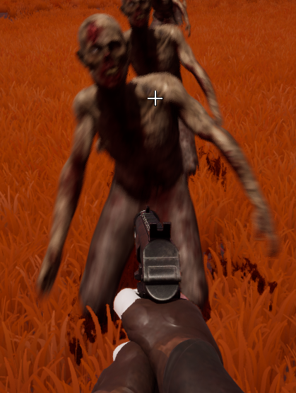

Figure 20 Applied enemy model

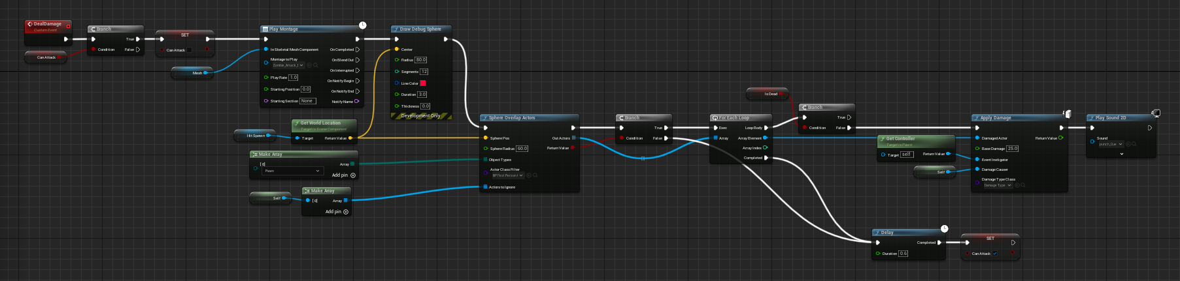

Table 22 Enemy damage function

## **Task #7. Display player taken damage visually as blood splatters.**

Damage indication was implemented by adding a blood screen [9] image to the player UI widget. Then on player hit, the alpha channel of this image was set to the corresponding health-to-max health percentage of the player.

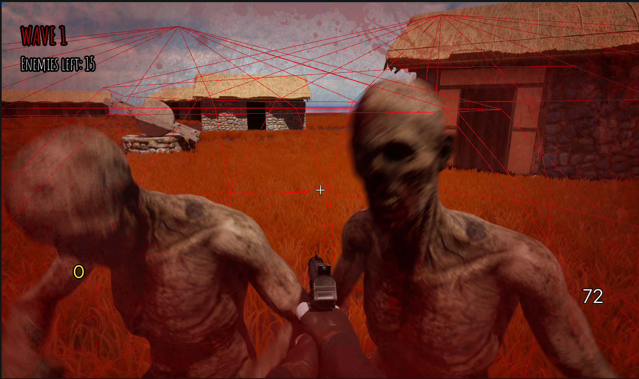

Figure 21 Blood splatter on screen

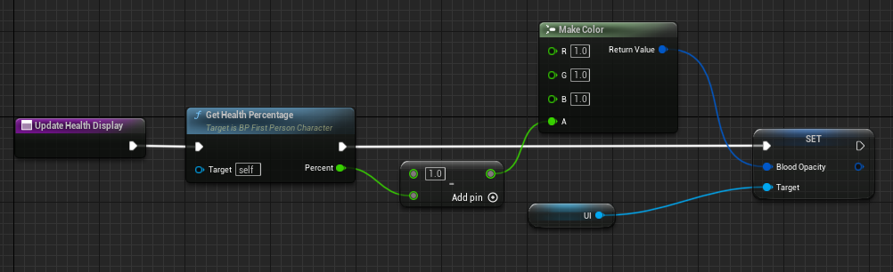

Table 23 Health display code

## **Task #8. Add enemy attack animation blend.**

For this task, an animation blueprint was created to store animation behavior. Using a similar method as the player’s animation blueprint, a blend between running and attacking was achieved.

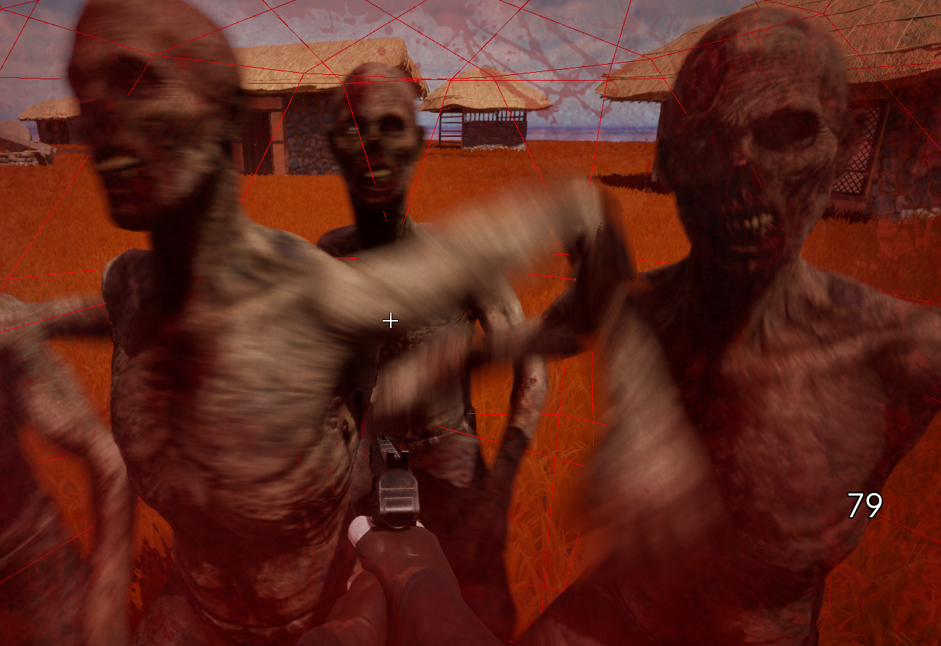

Figure 22 Enemy attack animation

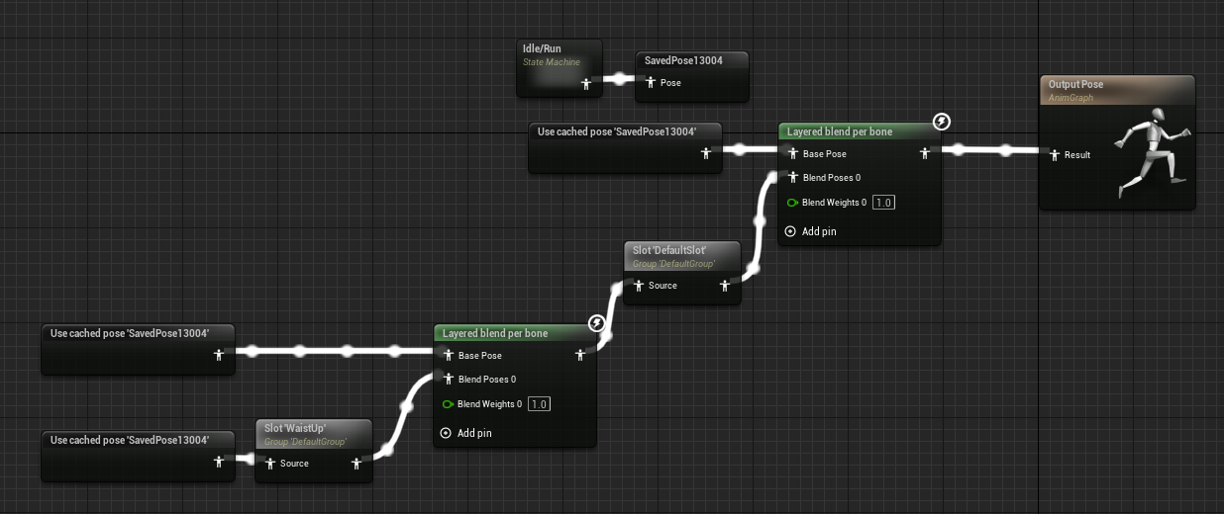

Table 24 Enemy animation blueprint

## **Task #9. Design an enemy wave spawn system.**

A wave system was implemented through the use of a GameMode blueprint. On scene start, this blueprint gets all custom enemy spawners, and depending on how big the wave is, adds enemies to a queue of actors to spawn. Once remaining enemies reach 0, the wave is ended, and a new wave begins to spawn.

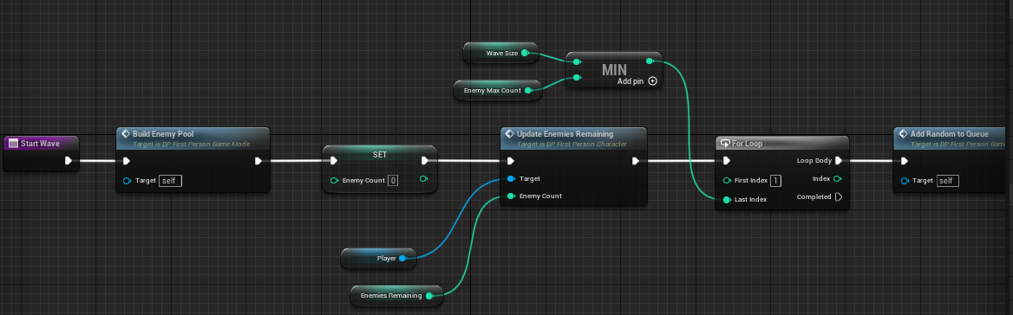

Table 25 Wave start function

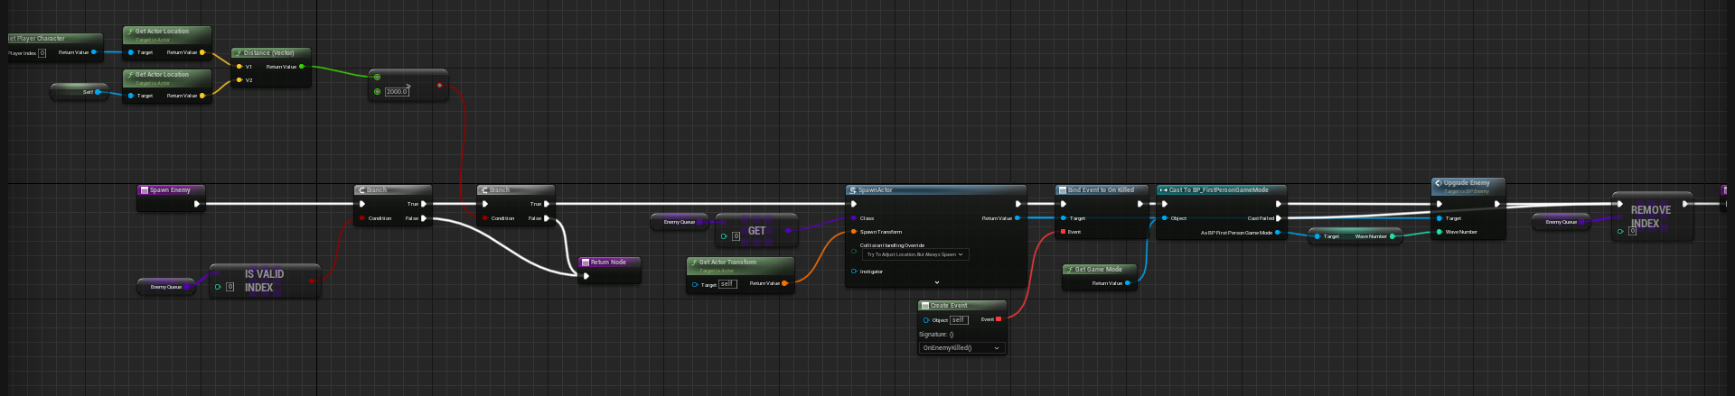

Table 26 Enemy spawn logic

## **Task #10. Add a weapon/ammo purchase mechanic.**

Added an extension to BP_WeaponPickupMaster that checks whether the player is wielding selected gun. If yes, instead of replacing the gun, it attempts to set ammo to max at half price. This is shown through a widget pop up that appears when getting close to selectable object.

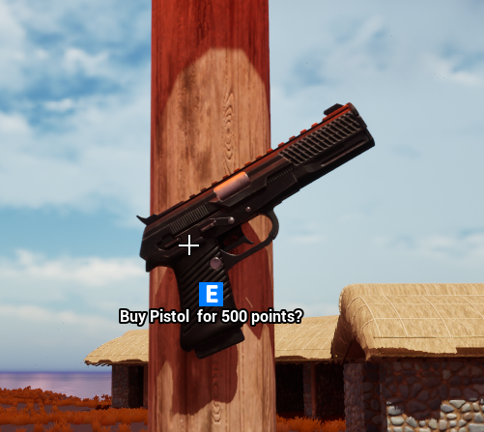

Figure 23 Purchase display

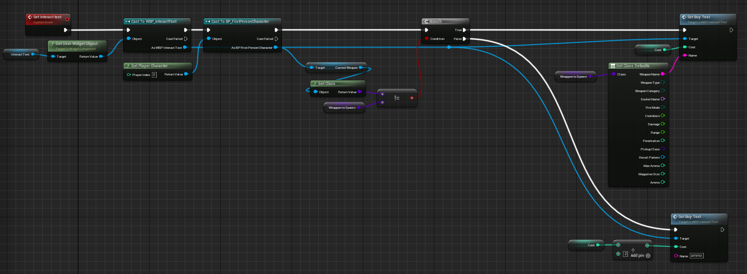

Table 27 Weapon purchase code fragment

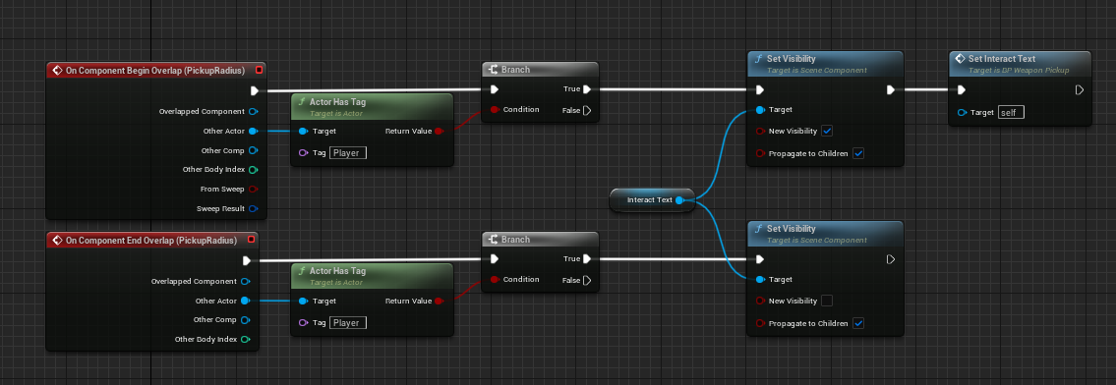

Table 28 Weapon display logic

## **Task #11. Add main menu.**

Added a starting level that lets player select if they want to play or quit. On level start, a widget that stores main menu UI is initialized. “Play” button starts main game level.

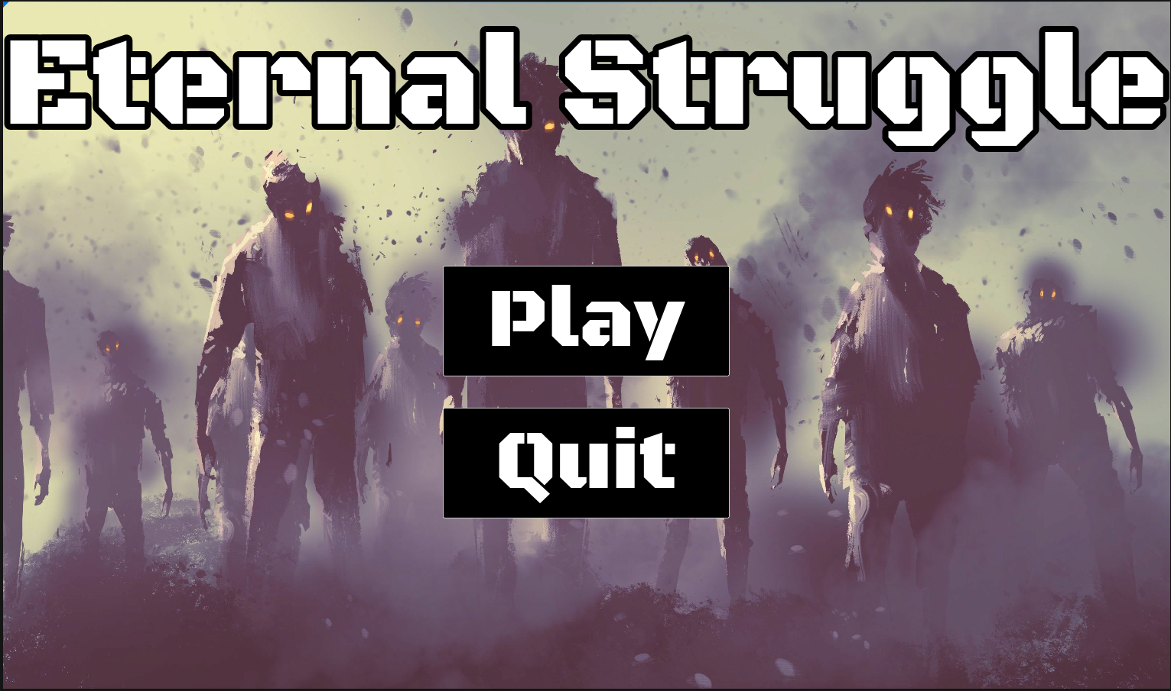

Figure 24 Main menu

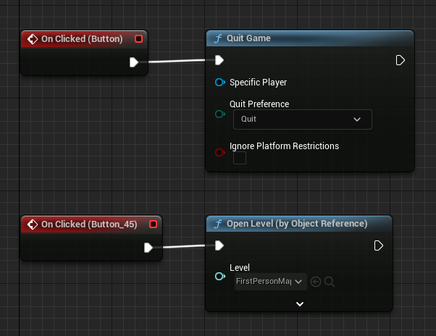

Table 29 Button functions

## **Task #12. Add game over menu.**

A game over menu was implemented similarly to the main menu. To display cleared waves and gathered points, a GameInstance bluepint cass was created for transferring data etween scenes. On player death, the GameInstance class saves collected points and wave count. They are then retrieved in game over screen.

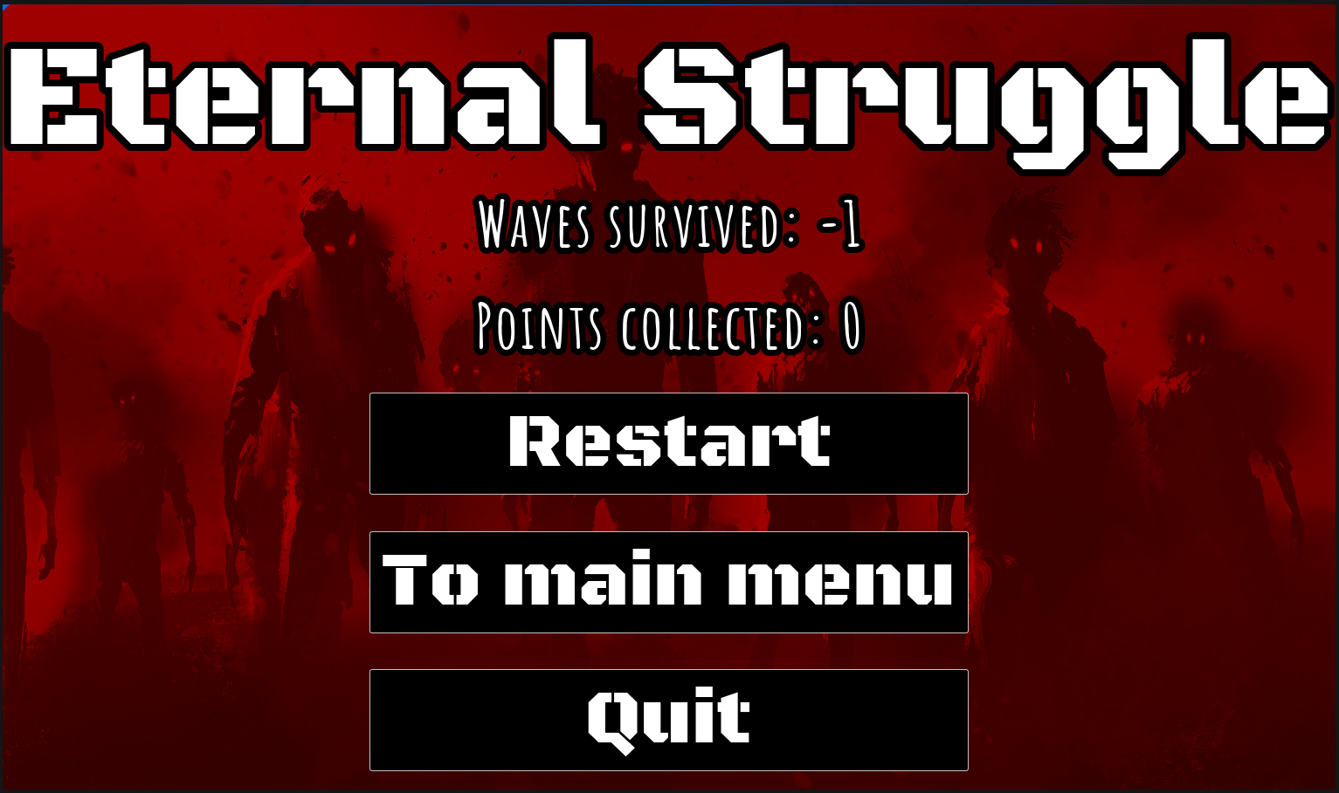

Figure 25 Game over menu

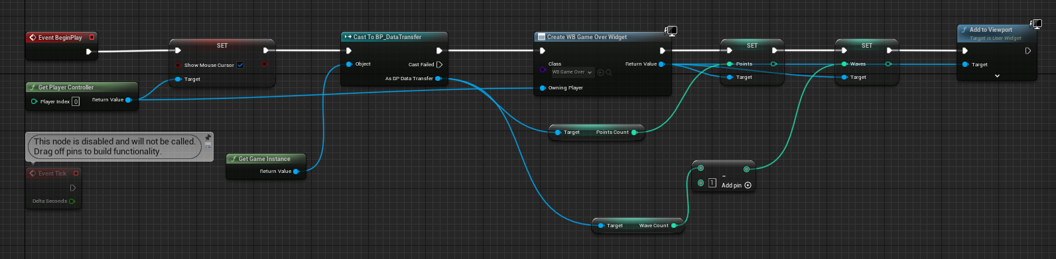

Table 30 Game over logic

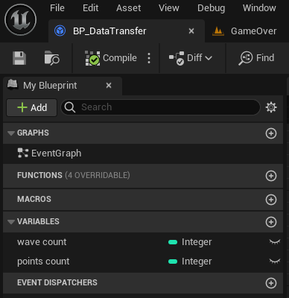

Table 31 GameInstance class

## **Task #13. Add pause menu.**

A pause menu was achieved by instantiating a widget. Since the default level escape for Unreal Engine’s editor is “Esc”, an additional key “P” was set to trigger pause menu functionality. In addition, user cursor display changes also required changing, since the main game’s view is controlled with a mouse.

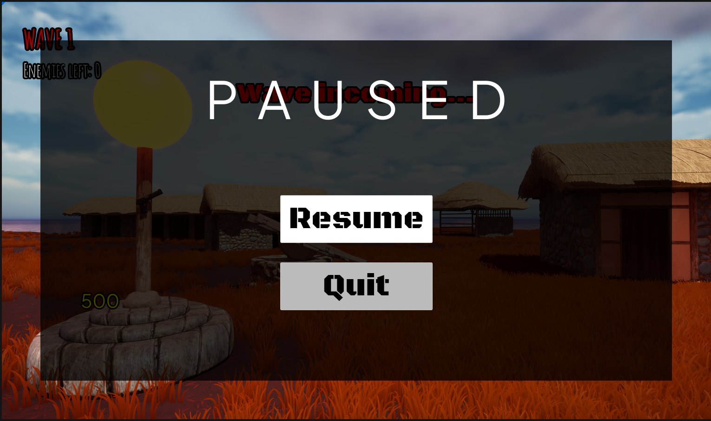

Figure 26 Pause menu display

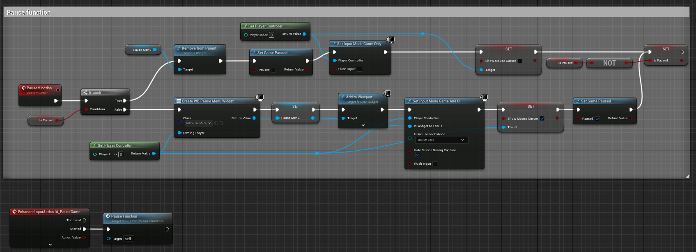

Table 32 Pause function logic

# **User's manual**

**How to play?**

Start the application by clicking on Eternal_Struggle.exe in the provided build folder.

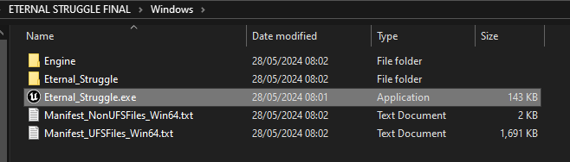

Figure 27 Executable file location

On application start, the main menu will appear as the first screen you see. At this point you can click “Play” to start the game, “Quit” to exit to desktop:

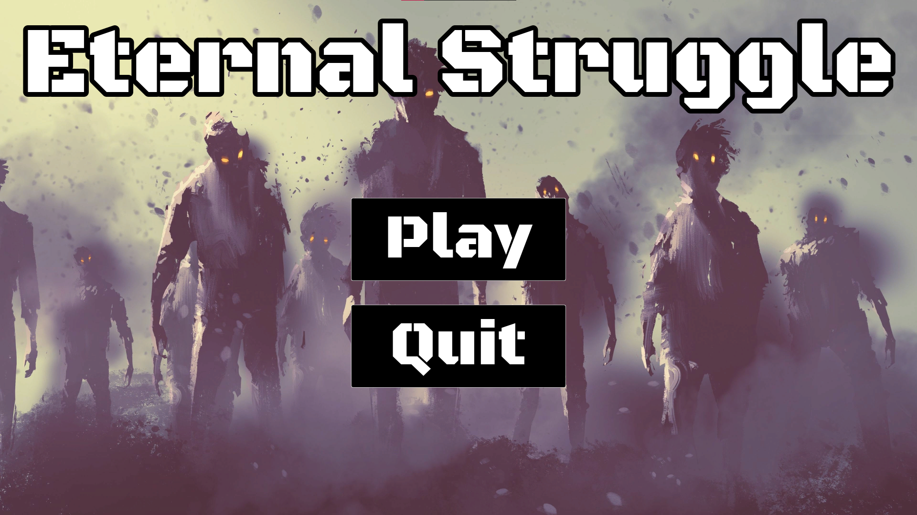

Figure 28 Application starting screen

After playing the level (or through the pause menu by clicking „Esc“ or „P“), you have the option to go to main menu or quit game:

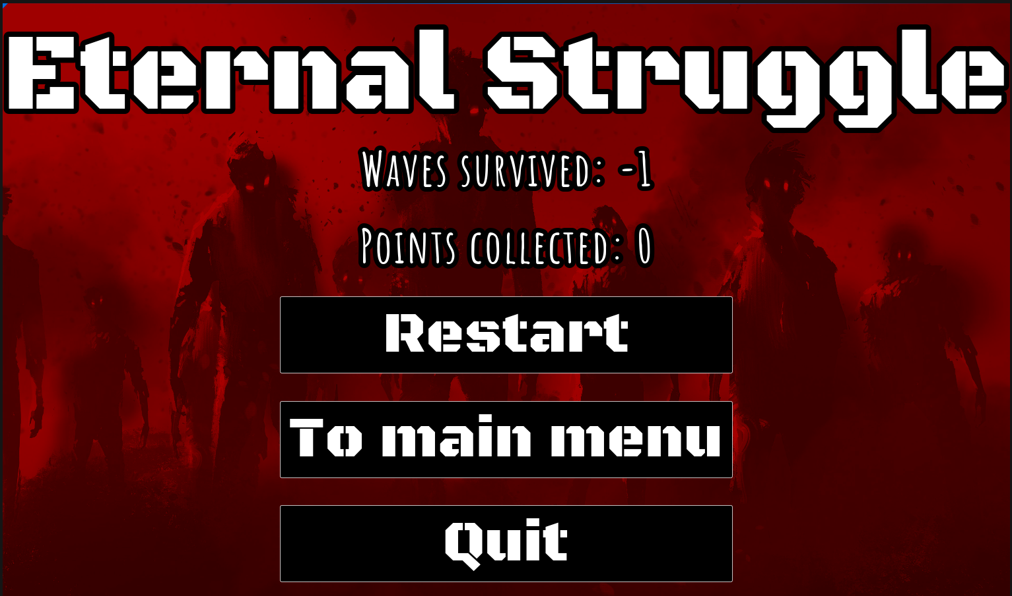

Figure 29 Game over screen

**Descriptions of the rules of the game**.

There is 1 main objective in this game: survive for as many waves as possible while collecting as many points as you can.

The player starts out with nothing but 500 points. At the start, the player is expected to buy the pistol in front of them for all the points they have. Bullets for already purchased guns can be bought from the same area at half the cost of the original gun price. These points can be earned hitting (10 points) and killing (50 points) enemies and are also the main score of the game. Therefore, to continue the game, the player must sacrifice some of their score.

Every wave, a certain amount of enemies spawn. Once a wave is cleared, the player is given a few seconds of spare time to restock on ammo or guns. Afterwards, a new wave of zombies begins to spawn with an increased enemy count and max health.

Zombies deal a fixed amount of damage that can kill the player if they receive too much in a short period of time, ending the game. However, after a few seconds, dealt damage will begin to heal if not interrupted with another attack.

**Descriptions of the controls / keys.**

* W, A, S, D – movement keys.
* Left mouse button – fire gun.
* Spacebar – jump.
* Esc/P – pause/resume game.
* E – interact with environment when prompted.

# **Literature list**

1. <https://www.unrealengine.com/marketplace/en-US/product/animation-starter-pack>
2. <https://www.unrealengine.com/marketplace/en-US/product/adventure-character>
3. <https://www.unrealengine.com/marketplace/en-US/product/easy-building-system>
4. <https://www.unrealengine.com/marketplace/en-US/product/military-weapons-dark>
5. <https://www.unrealengine.com/marketplace/en-US/product/nha-naganeupseong-walled-town-suncheon>
6. <https://www.mixamo.com/#/>
7. <https://pixabay.com/sound-effects/cash-register-kaching-sound-effect-125042/>
8. <https://pixabay.com/sound-effects/error-126627/>
9. <https://www.deviantart.com/7he1ndigo/art/Blood-Vignette-704205045>
10. <https://pixabay.com/sound-effects/punch-6-166699/>
11. <https://wallpapercave.com/4k-zombie-wallpapers>

# **ANNEX**

<https://github.com/ErnestasKu/Eternal-Struggle>

<https://ktuedu-my.sharepoint.com/:u:/g/personal/ernkup_ktu_lt/EQYXCLt5CT9MuPmqIYdxvlIBiUZVcrLo7Ra6YJ2whZJpqg?e=a77arG>